* It’s only bows and swords no American weapons
* [1:56 PM]
* It’s the French Revolution without firing weapon
* [1:57 PM]
* But the main character is an American coming from the future. I feel like it really is American to feel responsible for everything important that happens or has happened and revisit history (edited)
* [1:58 PM]
* And so I, as a game designer, I am revisiting the French Revolution and claiming that it was thanks to an American hero coming from the future
* U,{42beca36-84e7-456b-8b00-99a84803a3a8}{170},0.6666666666666666,0.6666666666666666
* **1**
* [2:00 PM]
* And so I come from the future I know exactly who to kill, where they will be, and when to kill them in order for the French to successfully lead their revolution
* [2:01 PM]
* But I only have a bow and a sword to not create a time disruption, but I have to be careful because if I miss, the enemies have old French riffles and they might kill me easily (edited)
* [2:02 PM]
* So it’s a very long range bow snipping game
* [2:02 PM]
* And you can move the camera to evaluate which angle to shoot with in order to hit a soldier at a given distance
* U,{e77368f9-a350-4cf0-8c75-066f01bd8c9c}{16},0.8333333333333334,0.8333333333333334

### Son Eminence, Yan — 02/19/2023 2:03 PM

You will only be provided the distance to the target, the angle, and other assisting tool but not the arrow trajectory prediction

* [2:04 PM]
* So the game should be focused on the physic engine
* [2:06 PM]
* And the animation cuz I want the arrow hitting to be satisfying. For example I thought of « real time evaluated animation » where the arrow split the body in two parts corresponding to the incoming trajectory
* [2:07 PM]
* That’s why I think the game should be with 2 colors and no more, in order to easily creates this animation
* **February 20, 2023**
* U,{e77368f9-a350-4cf0-8c75-066f01bd8c9c}{114},0.8333333333333334,0.8333333333333334

### Fujetus — 02/20/2023 12:32 PM

Okay I like the idea of American coming back from the future

* [12:32 PM]
* Thumbs up to all
* U,{e77368f9-a350-4cf0-8c75-066f01bd8c9c}{156},0.6666666666666666,0.6666666666666666
* **1**
* [12:32 PM]
* Gotta be the owners of all western world history
* U,{e77368f9-a350-4cf0-8c75-066f01bd8c9c}{189},0.6666666666666666,0.6666666666666666
* **1**

(old Id

Woke up

Bedroom

Music playing

Tv on

Music “good morning usa”

Gibberbish on the tv

Approach the tv zoom on the tv

It's the french revolution starting on the tv, king is like “I have a personal prison and you don’t"

Main character is mad

Eagle flying in the sky

Main character (Varun) is opening his personal secret men in black armory

Regular wood looking cabinet, inside many weapons

Zoom in, requires “murica eagle coins” to purchase, Varun is not American enough for the third and most expensive weapon “Daddy’s home” giga chad weapon, aka “Hollywood weapon” aka “gigachad weapon”

Instead proceed with the “Dogelore basic weapon” cuz he has just enough american xp to buy it

Goal : need to end the french revolution happening in his country, kill the king and become more american to buy the gigachad weapon

Proceed by opening the door

War

See a soldier, soldier is french so soldier doesn’t have a firing weapon, french king’s soldier running towards him

Text appears

“A person has tresppased your own land with probably violent intent, defend yourself !”

Choice: light philosopher choice, let the guy hurt you, the person is arrested and brang in front of the court (french way). No sure about that, but I want the game to be more than fun it has to also give the feeling “we live in a society”, the player should have the choice.

Or shoot him (your american right)

We will try to give a “we live in a society” feeling later.

Varun has most likely killed the trespasser.

Varun proceeds by entering the street.

At this point the game looks chaotic, tf is french, tf is american ?

Simple goal : shoot ppl, easiest choice

In the street ppl wants to kill the king and “liberate” the emprisoned persons in the Bastille

Maybe we should leave the “we live in a society” feeling for the player

Or

Ok I have an Idea, Americans living the french revolution in a modern era, same scripting, but no decision just shoot and kill. At the end Varun understands that killing and behading everyone like the french is not a solution, Varun learns from the french and become a super giga chad American – French person and is able to purchase the gigachad weapon which wasn’t available even with +infinity american xp

Possibility to earn french xp

As a gigachad Varun isnt shooting everyone, everyone is kneeling ?

The gigachad weapon isnt shooting ?

Also a hidden Zara boss american was available for the max american level, just a fun weapon

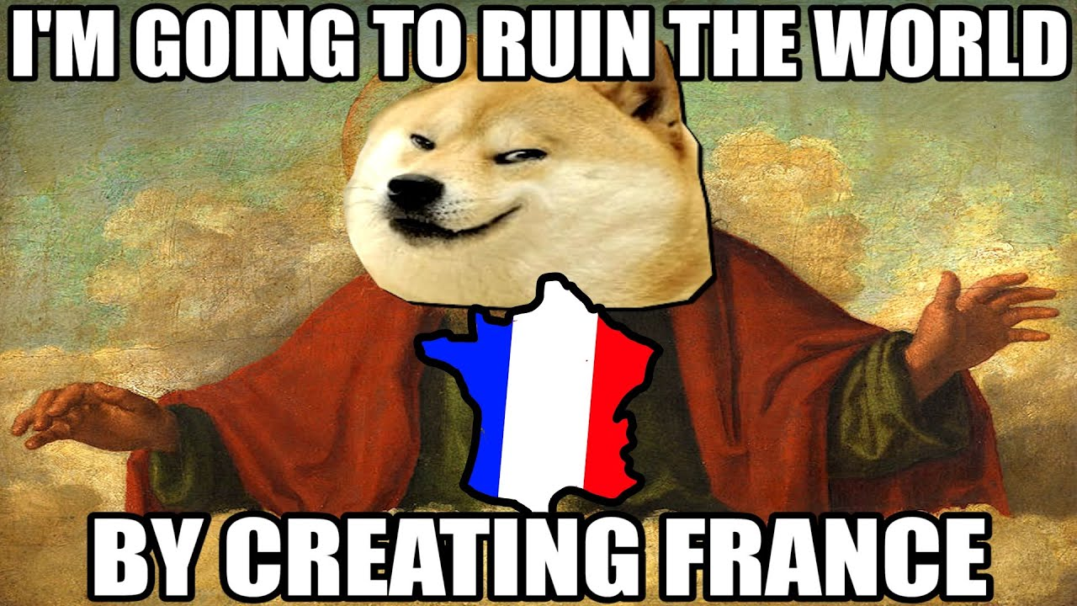

So

Varun in the streets, see the Bastille, Varun mad

Focus, the streets are silent